DARTS: Scientific Satellite Archives at ISAS/JAXA
K. Ebisawa¹, T. Tamura¹, K.Matsuzaki¹, I. Shinohara¹, A. Miura¹, H.Murakami¹，
K. Inada¹, Y.Kasaba¹ and H. Baba²
¹ Center for PLAnning and INformation Systems (PLAIN center),
Institute of Space and Astronautical Science (ISAS), JAXA,
3-1-1 Yoshinodai, Sagamihara, Kanagawa, 229-8510 Japan
ebisawa@isas.jaxa.jp
²Center for Research and Development in University Education, Ibaraki University,
2-1-1 Bunkyo, Mito, Ibaraki, 310-8512, Japan

Keywords: space science, satellites, database, archives

1. Introduction of DARTS
Data ARchives and Transfer System (DARTS; (http://darts.isas.jaxa.jp) is the scientific satellite data archives at Institute of Space and Astronautical Science (ISAS), developed and maintained by Center for PLAnning and INformation Systems (PLAIN center)[1],[2]. Development of DARTS started in 1997 with the aim of archiving scientific data of ISAS satellites as completely as possible. These data may be accessed via web-based interactive search system. Almost all the data at DARTS are publicly available; namely, researchers all over the world can retrieve the data as well as most analysis software by free of charge, and publish scientific results using these data. Future ISAS satellite data will be also made available via DARTS.
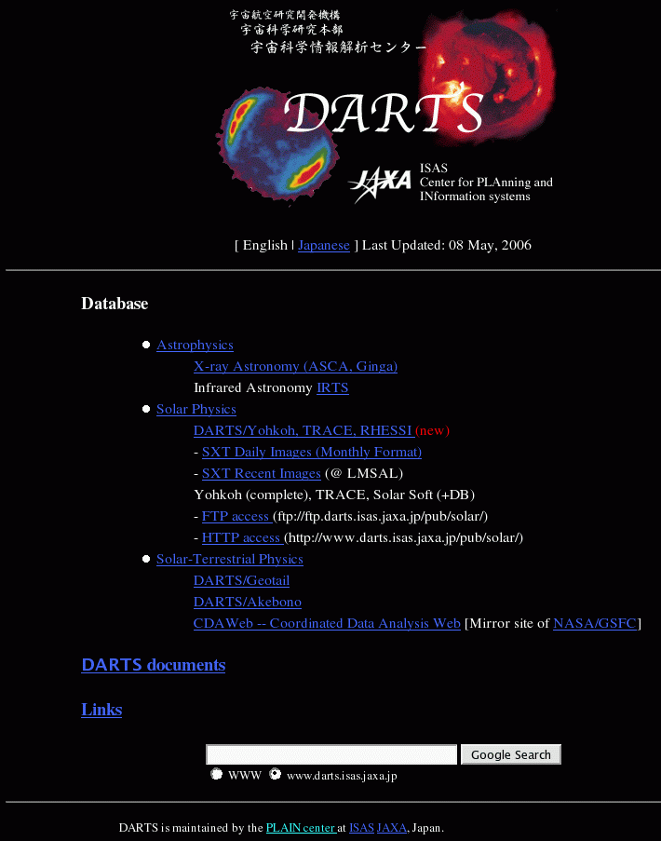
Figure 1. Top page of DARTS at http://darts.isas.jaxa.jp.

- ISAS Satellite Data and Network Systems
Figure 2 indicates a schematic diagram of the ISAS satellite data system. The telemetry data received at ground stations are sent to ISAS, and kept in the database named “SIRIUS”. SIRIUS keeps the raw telemetry data of all the ISAS satellites.
SIRIUS data may not be used for scientific study directly. Telemetry data are highly processed by the satellite mission teams, and scientific products are produced. In the case of astrophysical data, almost all the data products are in the standard FITS (Flexible Image Transportation System) format. Those high level scientific data products are archived in DARTS, so that researchers who are not familiar with the original telemetry data format can use the ISAS satellite data and produce scientific results.
Figure 2. A schematic diagram of the ISAS satellite data flow.
DARTS
SIRIUS
calibration
reformat
Mission
team
General
Users
Ground
stations

- Main services
The following table shows the list of ISAS satellites of which data DARTS is supporting:
Mission | Object | Contents
ASCA  1993-2000 | X-ray astronomy | Event data  QL products  Calibration data
Ginga  1987-1991 | X-ray astronomy | Telemetry data  Calibration data
Tenma  1983-1989 | X-ray astronomy | Observation log
HALCA  1997-2005 | Radio astronomy | Public data
IRTS  1995 | IR astronomy | Point source catalog, spatial intensity images
Yohkoh  1991-2004 | Solar astronomy | Reprocessed data, HK data, daily images
Geotail  1992- | Solar terrestrial phys.  (geomagmetsphere) | Magnetic field data, plasma moment data
Akebono  1989- | Solar terrestrial phys.  (aurora) | Observational data.
We also maintain the mirroring services TRACE, RHESSE (Solar physics), and CDA Web of NASA/GSFC (Solar Terrestrial Physics).

- Current Development
In 2005 July, Japan’s fifth X-ray astronomical satellite “Suzaku” was launched. Furthermore, in 2006 February, the first Japanese IR astronomical satellite Akari was lanched, and Japan’s third solar astronomy satellite “Solar-B” is waiting to be launched in September 2006. These three astronomical satellites are moderately large in ISAS missions (exceeding 1.5 tons), and data volumes are large (more than 1 Gbyte/day in raw telemetry). Also, all these satellite data will go public after short proprietary periods (one or two years). Hence the DARTS’s role as a public data archives will be very important. Currently, we are developing a new DARTS system primarily to satisfy requirements of Suzaku, Akari and Solar-B. The development is being made in the framework of the “TSUNAGI” middle-ware (next section).
Suzaku is a pointing satellite which typically observes one source per day. All the X-ray event data as well quick look products are archived. Development of Suzaku archives is conducted in cooperation of NASA/GSFC. The identical Suzaku archives are installed at ISAS and NASA/GSFC.
Akari is the first Japanese all-sky-survey satellite, and it will produce the most sensitive and comprehensive mid- and far-infrared all-sky source catalog. Number of the sources in the Akari catalog is expected to be more than a million. DARTS will have a capability to select stars which match the search criteria among many candidates. DARTS will provide a Character User Interface (CUI) as well as GUI so that users may specify, for instance, SQL queries directory. Akari also has the pointing observation modes, and those image data are also made public.
Solar-B will produce several Gbytes of data per day in X-rays, UV and optical lights. ISAS will be responsible for rather raw level data processing, and the higher level data (such as solar-flare movies) will be created at National Astronomical Observatory of Japan (NAOJ). However, not only the raw level data but also those high level data will be available at DARTS. ISAS and NAOJ are connected by a super-fast network (~1Gbits/sec), and the same database will be shared by ISAS and NAOJ. Solar-B DARTS will have an advanced quick look capability, so that users may see, for example, the solar-flare movies on the fly.

- Middleware “TSUNAGI”
In developing DARTS for several satellites, we should employ most efficient methods, since there are many similarities among the databases for different satellites. We want to eliminate duplication of developing efforts as much as possible. To that end, we have developed an innovative web-application development framework (middleware) named “TSUNAGI” (which means “connection” in Japanese). Two main aspects of the development for satellite databases are to register data and to search for data. TSUNAGI makes these two processes much easier for both researchers and engineers. In figure 3, we show a schematic diagram of web-application development using TSUNAGI.
Table
○○
○○○○
○○○○
:
△△
△△△△
△△△△
××
××××
××××
XCEN
DATE_END
DATE_OBS
・・・
△△
△△△△
・・・
○○
○○○○
･･･
XCEN]
観測日時

SOLAR-B DARTS
WEB browser
RDB
WEB
Application
FITS
files
×
TSUNAGI
REGISTER
SEARCH

Figure 3: A schematic diagram of the “TSUNAGI” middleware for efficient web-application developments.

To register data (FITS files) to RDB table, web-developers only need to define the data structure in the “definition files” with the XML format. Then TSUNAGI will produce java source codes to extract FITS header information and register in the RDB table.
Similarly, to build web-pages to search data, web-developers specify the requirements in the XML format configuration files. TSUNAGI produces java main source codes, and a skeleton of the business logic. Web-developers only need to write new business logic depending on the specific requirements for individual satellites. In this manner, we can save huge amounts of time and man-power to build web-application for new satellite database.
Future DARTS development will be made in the framework of TSUNAGI. TSUNAGI is also being exported outside of JAXA/ISAS, and expected to be a generic framework of web-application development.
- Future Plan
After Solar-B, ISAS has a series of accepted missions, Planet-C (2010; Venus mission), ASTRO-G (2011-; Space VLBI mission) and Bepi-Colombo (2013; Mercury mission) . DARTS will have public archives for these future missions too. We expect DARTS is going to be an indispensable resource for space scientists all over the world.

References
(1) Miura, A., Shinohara, I., Matsuzaki, K., Nagase, F., Negoro, H., Uno, S., Matsui, S., Watanabe, M., Yamashita, A., Takahashi, H., Matsui, H., & Hoshino, M. 2000, in ASP Conf. Ser., Vol. 216, Astronomical Data Analysis Software and Systems IX, eds. N. Manset, C. Veillet, D. Crabtree (San Francisco: ASP), 180
(2) Tamura, T., Baba, H., Matsuzaki, K., Miura, A., Shinohara, I., Nagase, F., Fukushi, M. and Uchida, K. 2003, in ASP Conf. Ser., Vol. 314 Astronomical Data Analysis Software and Systems XIII, eds. F. Ochsenbein, M. Allen, & D. Egret (San Francisco: ASP), 22

